Reintegration Flow Chart

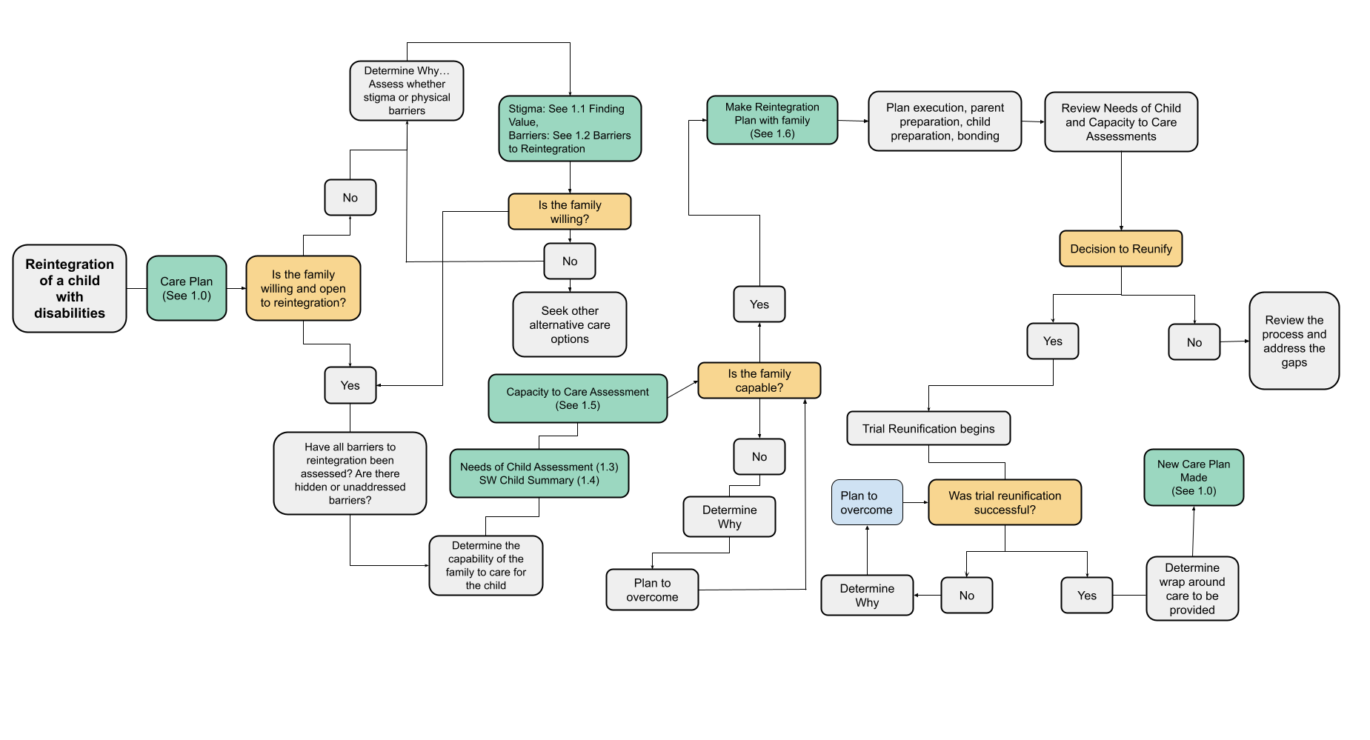

Appendix

Considerations and Challenges
1.0 Child Care Plan Template 4
General case management template for how parties will provide care to the child
1.1 Finding Value 6
A guide for social workers (and others) on how to guide a family through the journey of finding value in their child with disability
1.2 Barriers to Reintegration 6
A tool for case managers to identify the reasons why a family would not be interested in having their child back
1.3 Needs of Child Assessment 9
A specialized assessment tool to identify the unique needs of a child with disability and possible scenarios of how those needs might be met
1.4 SW Child Summary Template 12
A template to create a summarized version of the case history to be used at the time of decision making (i.e. reintegration, foster care, adoption)
1.5 Capacity to Care Assessment 13
A specialized assessment tool to assess a family’s capacity to care for the unique needs of a child with disability. To be used in conjunction with the Needs of Child Assessment. (This tool is similar to the CSI / FSI)
1.6 Reintegration Preparation Plan Template 26
A tool for the case manager to use if reintegration is a possibility. It will help identify how to prepare the family & child and steps that must be taken before the child is physically placed/reunited.

1.0 Considerations and Challenges
Reintegration is not an immediate process and it takes time to equip the identified family, preparing them as well as preparing the child for reintegration without leaving the community.
More so than in the cases of children without disabilities, Reintegration plans for children with disabilities will have more variability as they are individualized to each child and family. Each individualized plan will determine the process, steps, and timeline to prepare the child and family for placement.

Key Considerations: (how this process might differ from reintegration of typically developing children)
- The child care plan will address more areas
- The child assessment will address more areas
  - Ekisa’s “Needs of Child Assessment” factors in real life situations and inputs they child may receive to make case planning and decision making more realistic and effective
- Family assessments (the willingness and capacity of the family to meet the needs of the child) must be first informed by the individualized needs of the child
- Post-placement care plans need significant attention before a child is placed to ensure the child and family with have what they need to be successful
- Wrap Around care (a set of support to be extended to the child and family after placement)
- Team around the child - identifying a wholistic group of those involved in the child’s placement, care, and development
- Community participation and preparation is a key factor in success. The child must be accepted by their community

Common Challenges
- Cases that don’t work out: If after addressing the identified barriers, the case manager must decide whether to repeat the process or continue on with other alternative care options
- Unrealistic expectations from parents of the agencies
- Reintegration expenses
- Resistance from parents and communities - the child is not wanted or valued
- Concentration is often placed on mothers, leaving out the men who are fundamental in child upbringing
- Abstract barriers beyond the capacity of organizations
- Poor assessments that have gaps or are not factual/realistic. Good social work requires more than getting answers to questions and should be subjective.
- Absence of a multidisciplinary team from the organization

Overall Aims/Goals
- Permanency for the child
- Economic strengthening
- Sustainability
- Case Closure Transition… children with disabilities will most likely always need some sort of support and services.

1.1 Child Care Plan Template

Child’s Care Plan
Parties Involved: Insert parties involved such as parents, social workers, etc.
Major Goals: Insert major goals and objectives
Commencement Date: Expiration Date:

Child’s Full Name: |  |  | Date of Birth:
Parent’s/Guardian’s Name: |  |  | Telephone No.  ( )
Alternative Caregiver’s Name: |  |  | Telephone No.  ( )
Social Worker’s Name: |  |  | Telephone No.  ( )
Family Residence: |  |  | District:

Medical Summary:

Diagnoses
- List all the child’s current and suspected diagnoses here

Allergies
- List any known allergies here

Primary Goals: List top three child development goals for the next six (06) months

Medical
Medical Goals:
Staff Responsibilities | Caretaker Responsibilities

Social Work
Familial Goals:
Eisa Staff Responsibilities | Caretaker Responsibilities

Therapy
Therapeutic Goals:
Staff Responsibilities | Caretaker Responsibilities

Accommodations
Describe any accommodations the child needs in daily activities and why.
Feeding
Sleeping
Toileting
Mobility
Bathing
Other

Assistive Devices and Medical Supplies
Item | Use | Availability | If Not Available

Education
Education Goals:
Staff Responsibilities | Caretaker Responsibilities

Parent Education Plan
Name of Training (Topic) | Goal | Venue | When Training Will Occur

Emergency Plan Contacts
Nearest Hospital/Clinic
Social Worker
Field Nurse

Call the social worker if the child has any of the following symptoms or signs:

Social Worker’s Name: Parent’s Name:

Signature: Signature:
Date: Date:

1.2 Finding Value

Please visit https://www.ekisa.org/finding-value to download this guide.

1.3 Barriers to Reintegration

Barriers to Reintegration

Child’s Name: Caregiver Name:

Purpose of this planning document: As we assess whether the family is willing to care for the child, there may be certain barriers that they feel will hinder them from being able to take on the child. These barriers often come from families having a lack of information and false assumptions, leading them to the mindset that they don’t want the child back. Use this worksheet to assess those barriers and make a plan to overcome them.

Common Categories of “barriers”
- Education / Information
- Environmental
- Mindset/Attitude
- Communication
- Economic
- Services
Below you’ll find many examples of possible barriers you may face. When completing, start with a blank table and spend time thinking about each category individually and consider any barriers that you are seeing or assuming for that category. For each barrier you identify, please give at least one solution or way forward.

Category | Barriers | Enablers (Solutions)
Education / Information | - Lack of knowledge about child’s disability  - Skills and knowledge gap (i.e. the caregiver doesn’t know how to feed the child)  - No diagnosis | - Education (Finding Value)  - Feeding, diagnosis, needs, etc.  - Resource Mapping  - Doctors, Therapists, etc.
Environmental barriers | - Inaccessible house  - Safety  - Transportation to/from doctors appointments | - Ramps  - Budgeting for transportation  - Building  - Fences, pit latrines, corner seats
Mindset / Attitude barriers | - Myths and misconceptions  - Stigma/value  - Caretakers overwhelmed and exhausted from 24/7 care | - Disability awareness  - Counseling (Finding Value)  - Respite  - Connection with other caregivers
Communication barriers | - Child cannot speak  - Child does not know sign language | - Show the family other children that communicate without speaking  - Use of alternative communication methods such as PECS.
Economic barriers | - Limited to empowerment opportunities  - High illiteracy rates  - Family is not sure about increased costs having the child  - Not being able to take the child to work | - Supporting them to begin IGAs  - Calculate estimated costs for the child (medications, therapy, etc) and ways to pay for them  - Respite
Services | - Family doesn’t know what services the child will need  - Where can child access services | - Give families examples of other families and services their children receive  - Network with other service providers

1.6 Reintegration Preparation Plan Template

Reintegration Preparation Plan

Child’s Name: Caregiver Name:
Child’s DOB:

Purpose of this planning document: In order for the placement to be successful, what preparations are needed for the caregiver(s) and for the child before the date the child is placed. What areas of the capacity of the family need to be improved before that time? As you fill out all the following categories, think about and include when necessary….
- Clear action points
- Considerations
- Who, when, how, where

Pre-Placement Plan

- General Plan
  - It is recommended that (a child's name) should be reunified with (relative’s name), who is their (father, mother, etc). Living in (place)

- Finances
  - The only expected cost increase at this time is (food, transportation, medication, etc) at the estimated amount of (amount) shillings per month.
    - In order to meet this need the family will (how the family will ensure they have enough funding to meet this need, add multiple points if necessary)
    - In order to help the family meet this need Ekisa will (how Ekisa will assist, add multiple points if necessary)

- Accommodation
  - Accommodations that the family will need to make to their homes and/or lives include:
    - List any ways the family may need to change the layout of their home or their schedule/lives to have the child
      - Include how Ekisa may help them do these things

- Visitation Plan
  - In order to create an attachment and familiarize (child’s name) with their new/existing family and home the following visitation schedule will be followed.
    - (Add specific kinds of visits- at Ekisa house, family’s house, in community, overnight, etc and how long/often they will occur before moving to the next one, and proposed dates)

- Stakeholders
  - The following people are current members of the child’s team:
    - (List all, including family members, social workers, lawyers, teachers, etc)
  - Primary caregiver(s) at the child’s new home will be:
    - (List all, including name, relation to child, age, and how often/when they might be caring for the child)
  - Will there be an FGC?
  - Documents to be filled and signed
    - Reintegration Preparation Plan
    - Reintegration Expectations
    - Care Plan
    - Transfer letter
    - (Add/delete others as necessary)

- Risks
  - What risks are associated with this placement and how will they be addressed?
    - (List risk)
      - (How will it be addressed?)

- Caregiver Education (How/when/by who will the caregiver be educated/sensitized on the following:)

  - Health / Disability / Special needs
  - Food / Nutrition
  - Daily Care of child
  - Attachment
  - Communication
    - (How the child communicates)
  - Addressing Stigma
    - (Who will give this training, when will it be given)
  - Value of the Child
    - (Who will give this training, when will it be given)
  - Education for the child
  - Behavior
  - Therapy

- Ekisa Staff Preparation (How/when/by who will the Ekisa staff, especially caregivers, be informed of the plan:)

- Child Preparation
  - (How/when/by who will the child be informed of the plan,)
    - (Include any specific ways the child will be informed such as through a social story, video, book, in specific language, with AAC, etc.)
    - (Also include any other ways the transition will be made easier, such as special toys or objects that will go with the child)

- Timeline:
  - Review of plan and timeline to be: ___/___/____
  - Estimated completion of preparation plan: ___/___/____
  - Probationary period: Three months (to end on __/__/__)

Initial Post-Placement Plan

- Program
  - Home visit frequency:
    - During probationary period: (how often visits will occur)
    - (Other visiting periods and how often visits will occur)
  - After 12 months the family will be moved to the community care program

- Support Services Post Resettlement
  - What services will be provided after the placement?
    - (List service; medication, food, therapy, education, clothing, respite, social work, etc)
      - (How will it be provided and for how long)

I acknowledge that I have read and understood these expectations. I also acknowledge that I have voiced my questions and concerns, they have been answered and addressed, and I will abide by these guidelines set forth by Ekisa Ministries during the child’s resettlement process.

_____________________________________
(Relative’s name)

_____________________________________
(Social Worker Name), Social Worker, Ekisa Ministries

Date:_______________________________

